Chapter 3, Problem 93

Rework Example 3.11 with hand calculation.

Example 3.11

In the circuit in Fig. 3.34, determine the currents i₁, i₂, and i₃.

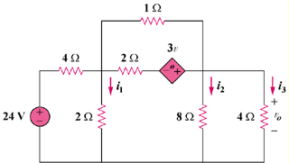

Figure 3.34
For Prob. 3.93.

